1. Add Gas Cartridge type image on : <https://ambalafiresafety.com/water-fire-extinguishers/>
2. While Clicking the types of DCP Fire Extiguiser page, It will redirect to the separate page of a type like (/BC fire extinguisher) and (/ABC fire extinguisher).: <https://ambalafiresafety.com/dcp-fire-extinguishers/>
3. Remove those Products and add relevant image of the link: <https://ambalafiresafety.com/afff-fire-extinguishers/>

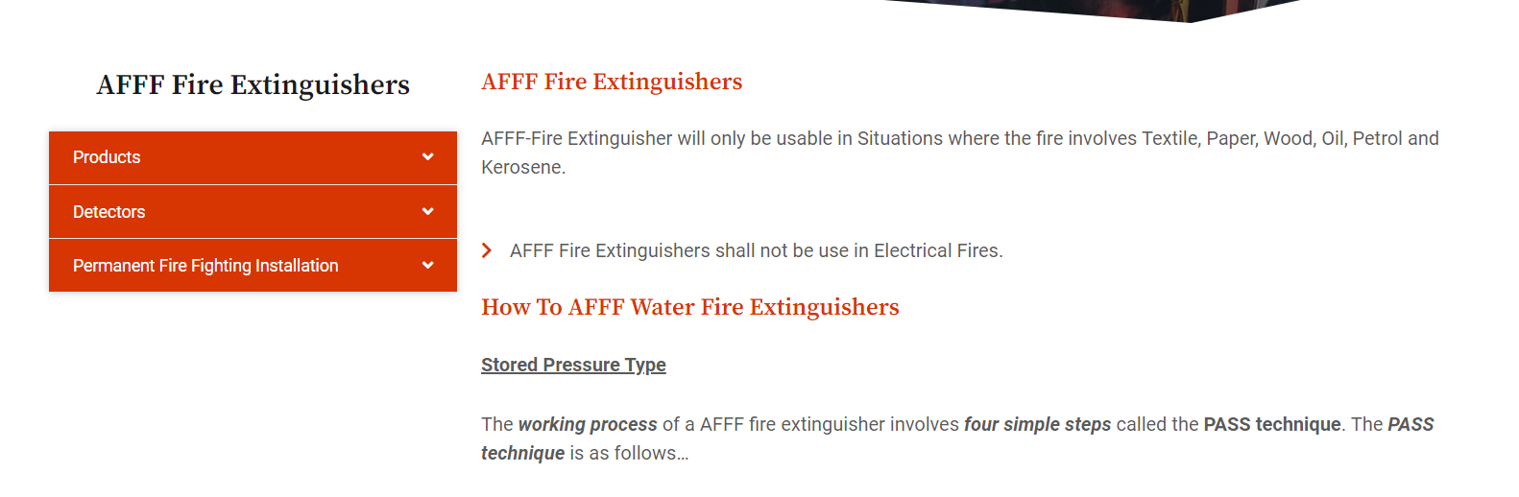\*(Check the above point for all pages)

1. Add trolley mounted fire extinguisher image on: <https://ambalafiresafety.com/trolley-mounted/>
2. Redo the same thing of point no.2 for trolley mounted/DCP Fire Extiguiser page
3. Replace the Semi-automatic category with an Automatic Modular type Fire Extinguisher.
4. While Clicking the types of Automatic modular type Fire Extiguiser page, It will redirect to the separate page of a type like (/DCP fire extinguisher) and (/Clean agent fire extinguisher)
5. Above (/DCP fire extinguisher) have two categories same as point no.2.

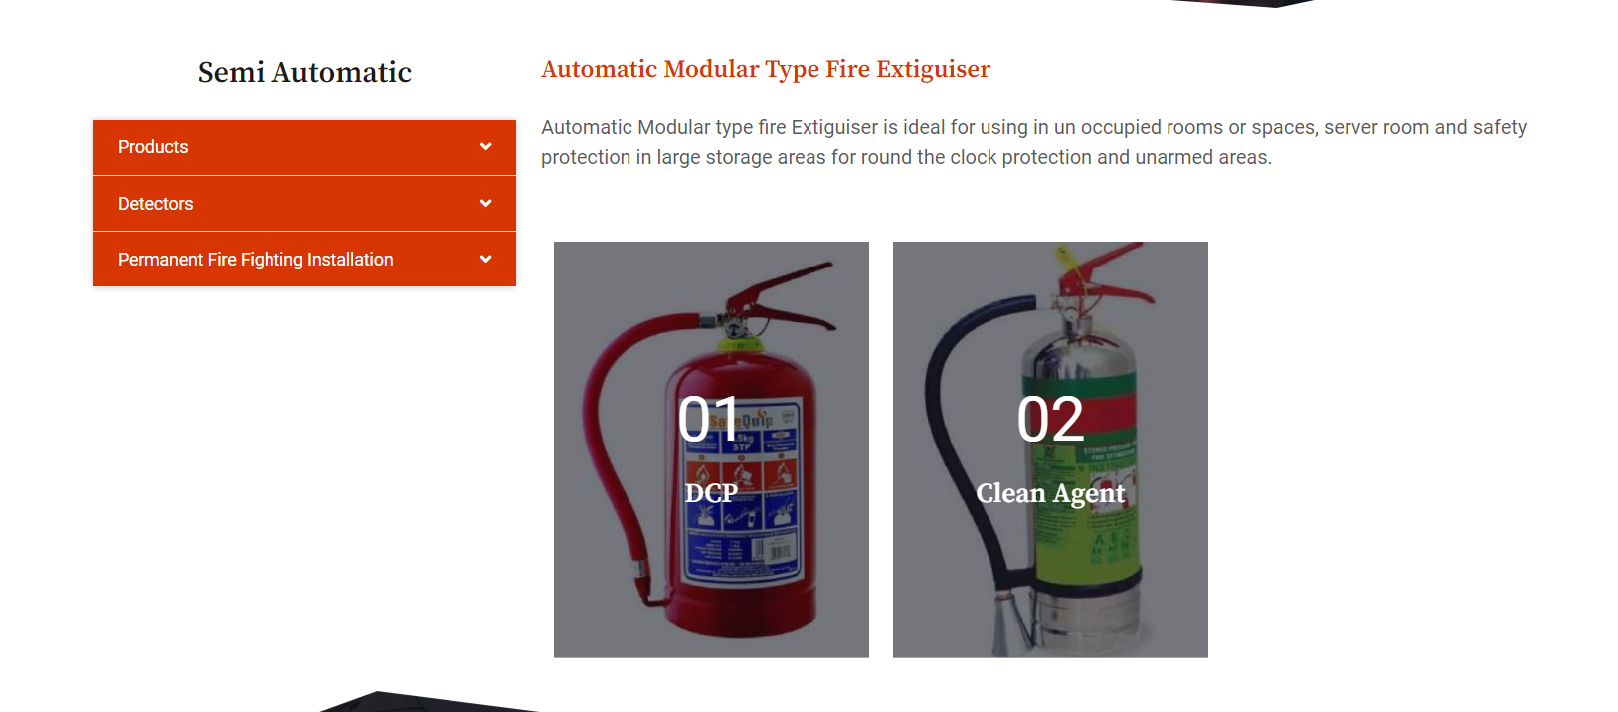

1. Add Roof-mounted fire ext image on: <https://ambalafiresafety.com/semi-automatic/> (Change this url to htts://ambalafiresafety.com/ Automatic Modular type Fire Extinguisher).
2. Add Logo (Added in the attachment).